Resource Guide: Water Walks
  - August 2026

Prepared by:
Majestic Moerland- Just Waters Indigenous Summer Student Intern
Sarah Deckert - Just Waters Project and Knowledge Mobilization Coordinator

Contents
Water Acknowledgement 3
About the Resource Guide 4
Podcasts 5
Songs 6
Children’s Books 6
Videos 7
Websites 8
Curricula and Toolkits 9
Media Articles 10

Water Acknowledgement
The Just Waters project and the Centre for Human Rights Research (CHRR) are based in Winnipeg, Manitoba on the original lands of the Anishinaabeg, Ininiwak, Anisininewuk, and Dakota Oyate, and the National Homeland of the Red River Métis. We honour the lands, waters and relationships that sustain us.
The Just Waters team is based in the Lake Winnipeg watershed and acknowledges the lake and the many waters that flow into it including the Red, Winnipeg, Saskatchewan, Poplar, Berens, Pigeon, Manigotagan, Dauphin, Fisher, and Icelandic rivers. This lake, called Weenipagamiksaguygun in Anishnaabemowin, has been harmed by nutrient-loading from agricultural run-off, livestock production, and sewage. Wetlands, which would normally protect the lake, have been drained for agricultural and construction purposes. These harms have impacted the traditional lifeways and relationships of the peoples that have lived with Lake Winnipeg for many generations.
We acknowledge that Winnipeg’s drinking water comes from Shoal Lake, and that this led to Shoal Lake 40 lacking access to clean drinking water for more than two decades. Many First Nations communities do not have clean drinking water, both because of a lack of water treatment and distribution infrastructure and because source waters have been polluted.
We also acknowledge that the production of Manitoba’s hydroelectric energy often results in the displacement of Indigenous peoples and their communities from their land, as well as flooding, shoreline erosion, changes to water quality, disruption to fishing and hunting, and the destruction of habitat.
We offer this water acknowledgement to promote a shared understanding of the history that has led us to this moment. This history is a history of colonial violence, Indigenous dispossession, and environmental harm, as well as of Indigenous resistance, knowledges, and resurgence. The Just Waters project aims to address this settler colonial violence and to think about water from a relational, rather than a resource, perspective. To this end, we express our gratitude to the waters that sustain us.

About the Resource Guide
We hope that this resource guide will support you as you learn about water walks and perhaps even prepare to join a water walk in your community. We created this guide in preparation for Miskwaagamiiwi-ziibi Water Walk on September 23, 2026.
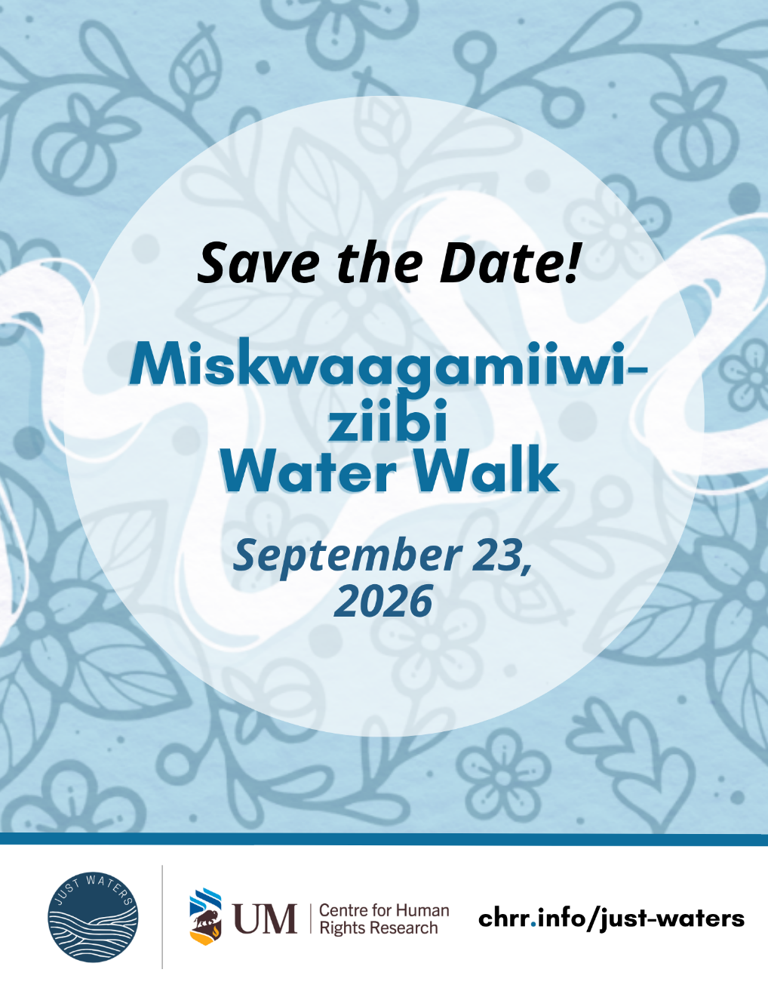

Podcasts

The Akiiwan Podcast – Nibi

Episode 4, “Nibi,” features water protector Taylor Galvin discussing our relationship to Nibi in 3 different interviews (2020).

Autumn Peltier – The Water Walker
This Ahkameyimok Podcast with Perry Bellegarde features Autumn Peltier sharing her story on being a water walker, her personal life experiences, and her advocacy work within water protection.

Undercurrents – Water Walking
This MCC podcast features the voice of Indigenous Water Walker Mary Anne Caibaiosai. This episode discusses water walks protocols and the spirit of water. Transcript and discussion guide for the episode are available.

Unreserved with Rosanna Deerchild – Water is sacred
This CBC podcast discusses how water is life and advocates for water protection, featuring stories from Stephanie Thorassie, Josephine Mandamin, Shirley Williams, Elizabeth Osawamick, and Pamela Palmater.

What About Water? With Jay Famiglietti – Tasha Beeds: Walking With Water
On this episode of What About Water? Jay sits down with Tasha Beeds, a grassroots Indigenous academic and Water Walker. She takes us through the origins of Water Walking, an Indigenous ceremony recognizing and connecting with water. Beeds enters into ceremony for the water, discussing what it means to raise consciousness about water as a living entity.

What About Water? With Jay Famiglietti - World Water Day 2023 with Autumn Peltier
In this bonus episode for World Water Day 2023, Peltier and Jay discuss what it was like to shoot her documentary The Water Walker, as well as her activism as a youth.

Songs

Nibi Song

By Doreen Day
This site includes audio, the story of the Nibi Song, and a pronunciation guide. Doreen and her grandson, Mashkoonce, give permission for everyone to share this song and sing it to the water.

Nibi Nagamoonan: Water Songs
Decolonizing Water and Grand Council Treaty #3 are excited to present the Water Songs video which shares a glimpse into the knowledge and songs that were exchanged throughout the project.

Nibi Walk: Nibi Songs
Includes recordings of Gi Bimosayaan nibi ohnjay M’de waboo (We walk for the water. Sacred Water.) by Sharon Day and The Water Song brought by Dorene Day.

Children’s Books

Autumn Peltier, Water Warrior

by Carole Lindstrom, illustrated by Bridget George
Inspiring picture book biography about two Indigenous Rights Activists, Josephine Mandamin and Autumn Peltier. Find a read-aloud video at So’oh Story Time.

Nibi Emosaawdang / The Water Walker

by Joanne Robertson, translated by Shirley Williams, Isadore Toulouse
The story of determined Ojibwe Grandmother (Nokomis) Josephine-ba Mandamin and her great love for Nibi (water).

Nibi is Water, Nibi aawon nbiish

by Joanne Robertson, translated by Isadore Toulouse, Shirley Williams
A first conversation about the importance of water, told from an Anishinaabe (Ojibwe) perspective.

Sharon Day: Water Walker

by Pauline Danforth, Illustrated by Tashia Hart
From her water protector walks to her other work as an Ojibwe activist, learn all about the life of Sharon Day.

Walking with Miskwaadesi

Writing and editing contributions by Eileen “Sam” Conroy (Wahgeh Giizhigo Migizi Kwe), Andrea Harquail, Bob Johnson, Basil Johnston, Kaitlyn Watson, Kim Wheatley (Shkode Neegan Waawaaskone), Shirley Ida Williams (Igizi Ow-Kwe), illustrations provided by Bernice Gordon.
This book provides readers with insight into the Traditional Knowledge of the Anishinaabe Peoples whose traditional lands surround the Great Lakes. Chapter 8 – The Importance of Water tells a story of Nokomis Annie meeting Elder Josephine Mandamin. Chapter 9 – Water: Our Business discusses the importance of protecting and honoring our relationship with nibi.

Videos

Autumn Peltier: RRU Changemakers Speaker Series
This YouTube video uploaded by Royal Road University features a discussion with Autumn Peltier, and the full 12 minutes of her movie The Water Walker.

Josephine Mandamin: Grandmother Water Walker
Canada Post created this video in honour of Josephine Mandamin, when they created a stamp featuring Mandamin as part of the 2024 Indigenous Leaders series.
Josephine Mandamin: The Anishinaabe woman who walked for water rights
This is a short YouTube video on water walks uploaded by Historica Canada, illustration by Kyle Charles, narrated by Josephine Mandamin. Historia Canada has an activity in Canada History Week 2020 Learning Tool to follow along with the video.

Salt River Water Walk
In February 2020, Sharon Day came to Arizona to lead a Nibi Walk from the headwaters of the Salt River to the confluence of the Salt and Gila Rivers. She was accompanied by a group of Indigenous youth, as well as other Water Walkers from her home state of Minnesota. Includes MMIWG2S+ representation within the walk.

Sherry Copenace – Relationship to Water Series
This short YouTube video uploaded by Lake Winnipeg Indigenous Collective, features Elder Sherry Copenace of Onigaming First Nation speaking on the responsibility of taking care of water.

Step by Step, Wave by Wave: A Water Walker’s Story
Interview with Mary Anne Caibaiosai of the Grand River Water Walkers.

The Water Walker
The Water Walker is a stunning documentary-animation hybrid tracing the roots, passion and perseverance of leading International Indigenous rights and water activist, Autumn Peltier while following her journey at 15 to New York City to stand up and address The United Nations about the destruction of the youth's future and environment. Requires subscription, or you can watch at minute 8:25 here. Read this article about the movie.

Water Walkers
Feature on Anishinaabe children's book author/illustrator Joanne Robertson, who was a Water Walk planner behind the scenes for Nokomis Josephine Mandamin.

Websites

All Nations Grand River Water Walk
This website covers The All Nations Grand River Water Walk. This site contains information about the water walk, dates of future Grand River Ceremonies, photo gallery, and more.

Credit River Water Walk
This website contains information regarding the 2026 Credit River water walk. Links to protocols and instructions for people wanting to join.

Native Womens Association of Canada – Water Carriers
This website covers the phases of the NWAC's Water Carriers Project. This page contains various resources consisting of videos, reports, and newsletters.
NibiWalk- Every Step is a Prayer
Website with multiple resources including songs, photos and stories about Nibi Walks.
Mother Earth Water Walk
Mother Earth Water Walk includes photos, video, journal entries and more from the thirteen water walks that Grandmother Josephine Mandamin walked between 2003 and 2017.

Watersheds Canada
Watersheds Canada has an Indigenous water education webpage. Explore stewardship actions rooted in traditional knowledge and understand different cultural perspectives on the protection and preservation of water! Learn about Water Walks, the Sacred Water Circle, Indigenous water governance, and why water is sacred.

Curricula and Toolkits

Biinaagami Giant Floor Map
For those living in the Great Lakes-St. Lawrence watershed, Canadian Geographic Education will ship you Biinaagami Giant Floor Map with an 11-lesson teachers’ guide. Activity 2 is about water walkers.

Canada History Week 2020 Learning Tool - Activity 3 Water Activism: Josephine Mandamin
This learning tool by Historica Canada provides multiple research and classroom activities. Activity 3 Water Activism: Josephine Mandamin focuses on water activism and environmental racism.

Operation Water Spirit
Operation water Spirit (OWS) contains a collection of presentations and lesson plans surrounding Indigenous culture and perspectives involving water, water issues, and water ceremonies. These lessons cover K – 12. Grade 10-12 Lesson 1: Water In First Nation Ceremonies discusses water walks and other ceremonies involving water.

The Water Walker: Indigenous Wisdom and Water Contamination
This STEAM curriculum for middle grade students includes clips from the film The Water Walker courtesy of Seeing Red Media.

The Water Walker Teacher’s Guide
Second Story Press provides teachers’ guides for both the English and Anishinaabemowin versions of The Water Walker.

Water is Life
This learning package has been created as an extension of the Indigenous Peoples Atlas of Canada Giant Floor Map learning activities. It was written by Jaime Black, an Indigenous educator, artist, and the founder of the REDress Project. The four lesson plans draw on land-based learning, centered on women’s teachings about, for, and from Mother Earth, with a specific focus on water and its connection to land and the Indigenous Peoples living on Turtle Island. The learning package is designed for students in grades 6-12 but can be adapted for younger students.

Water Walkers
A resource for educators to accompany Nibi Emosaawdang / The Water Walker by Joanne Robertson.

Grand River Water Walk Ideas for Schools
The All Nations Grand River Water Walk includes some ideas for lessons and projects on their website.

Isaac Murdoch and Christi Belcourt Banners
These banner images are being made available by the artists, Isaac Murdoch & Christi Belcourt, free to download and use in support of water and land protection. These are for NON-PROFIT, NON-COMMERCIAL use only.

Media Articles

A Prayer not a protest
This Canadian Geographic feature covers information on Métis Elder Marjorie Beaucage and a water walk along the South Saskatchewan River.

Formal statement regarding appropriation of Mother Earth Water Walk and Josephine (Biidaasige)-ba Mandamin's legacy
Anishinabek News statement on behalf of the late Grandmother Water Walker Josephine (Biidaasige)-Ba Mandamin's Estate.

Indigenous, allies preparing for water walk through Halton Hills and beyond.
Halton Hills Today feature on water walk through Halton Hills along the Credit River.

Peterborough youth organize water walk led by Elder Dorothy Taylor to honour Little Lake.
KawarthaNOW article by GreenUP on water walk ceremony involving students.

'Water is our responsibility,' say Indigenous community reps leading water walk across P.E.I.
CBC News feature on a water walk in Prince Edward Island.

Water walk ceremony welcomes community to care for water in Thunder Bay, Ont.
CBC News feature on a water walk ceremony around Boulevard Lake in Thunder Bay, Ont.

Water Walk highlights spiritual and environmental connections
Cambridge Today news release on The All Nations Grand River Water Walk.

Water walkers plan ceremony along entire St. Croix River.
St. Croix 360 feature by Greg Seitz on water walk along the St. Croix River.

